**UNIVERSITY OF MUMBAI DEPARTMENT OF COMPUTER SCIENCE**

M.Sc. Computer Science – Semester IV

**ROBOTICS**

JOURNAL 2022-2023

SEAT NUMBER

 

UNIVERSITY OF MUMBAI

# DEPARTMENT OF COMPUTER SCIENCE

**CERTIFICATE**

This is to certify that the work entered in this journal was done in the University Department of Computer Science laboratory by Mr./Ms. Seat No. for the course of M.Sc. Computer Science - Semester IV during the academic year 2022 - 2023 in a satisfactory manner.

**Subject In-charge Head of Department**

**External Examiner**

# Index

|  |  |  |  |  |
| --- | --- | --- | --- | --- |
| **Sr. No** | **Content** | **Page No.** | **Date** | **Sign** |
| 1 | Making Raspberry pi headless and reaching it from the network using Wi-Fi and SSH. | 1 | 11/2/23 |  |
| 2 | Using sftp upload files from PC | 5 | 18/2/23 |  |
| 3 | Write a python code to test motors | 13 | 25/2/23 |  |
| 4 | Write a script to follow a predetermined path | 14 | 4/3/23 |  |
| 5 | Develop Python code for testing the sensors. | 17 | 11/3/23 |  |
| 6 | Add the sensors to the robot object and develop the linefollower behaviour code | 18 | 18/3/23 |  |
| 7 | Using Light strip to develop and debug the line follower robot | 22 | 25/3/23 |  |
| 8 | Create an obstacle avoidance behaviour for robot and test it. | 26 | 1/4/23 |  |
| 9 | Detect faces with HAAR cascades | 30 | 8/4/23 |  |
| 10 | Using the robot to display its camera as a web app on a phone or desktop and then use camera to drive smart colour and face tracking behaviours. | 31 | 29/4/23 |  |

**Practical 1**

**Aim**: Making Raspberry pi headless, and reaching it from the network using wifi and SSH..

**Components:** SD Card -16 Gb, Desktop

**Procedure:**

**Step I. Go to** [**www.raspberry.com**](http://www.raspberry.com/) **and click on software tab. Download raspberry pi imager for windows. And connect SD card to laptop.**

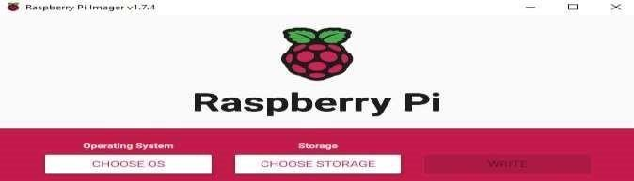

**Step II. Select operating system (raspberry pi OS 32-bit)**

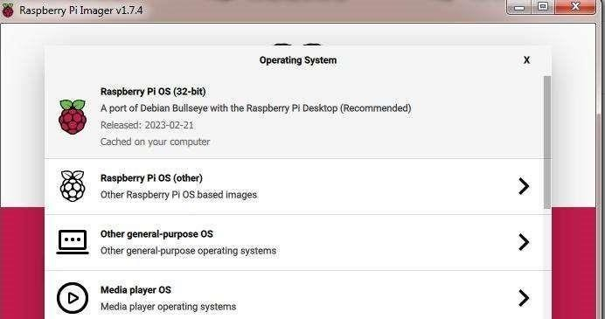

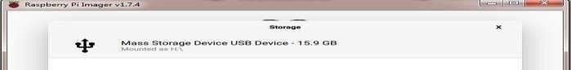**Step III. Select Storage**

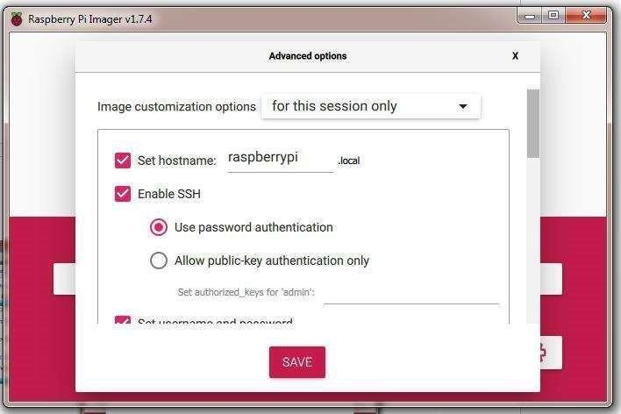**Step IV. Click on Setting Icon. and set hostname. Click to enable SSH**

**Step V. Click to configure wireless LAN. And select country.**

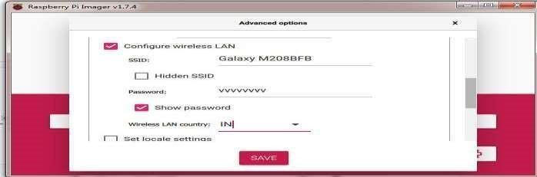

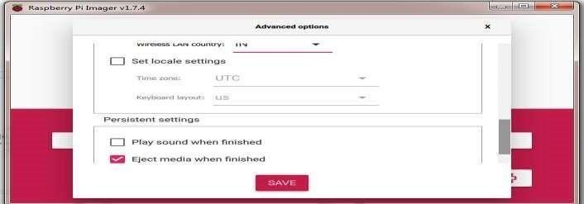**Step VI. Click to save.**

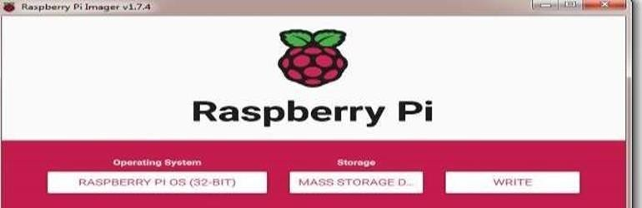**Step VII. Click on write.**

**Step VIII. Click on yes.**

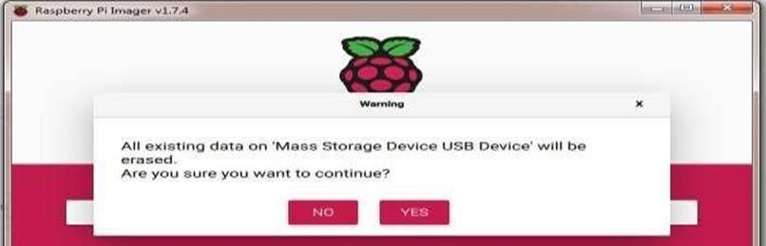

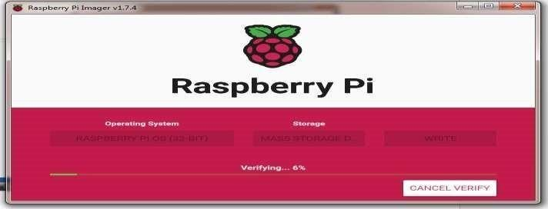**Step IX. Verifying raspberry pi .**

**Step X. Click on continue**

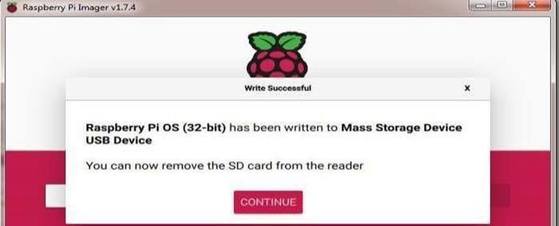

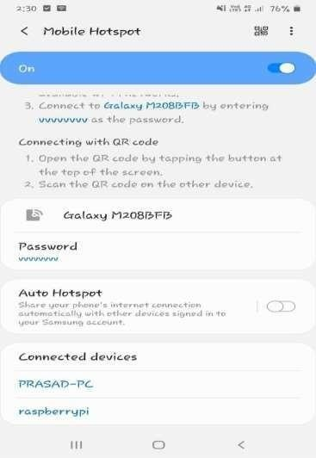**Step XI. Check the connection in your mobile hotspot of raspberry pi**

**Step XII. On cmd prompt execute these command:**

1. **ping raspberrypi**
2. **ssh admin@raspberrypi**

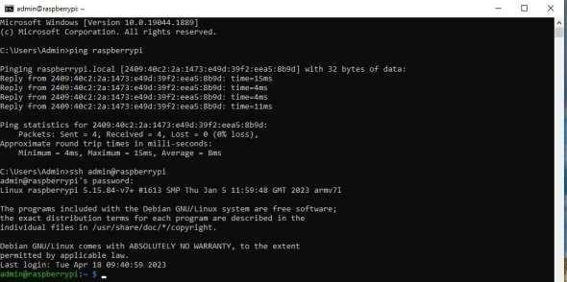

# A screenshot of a computer Description automatically generated with medium confidencePractical 2

**Aim**: Using sftp upload files from PC **Software required:** FileZilla, GitHub **Procedure:**

**Step I. Install the Raspberry Pi Imager**

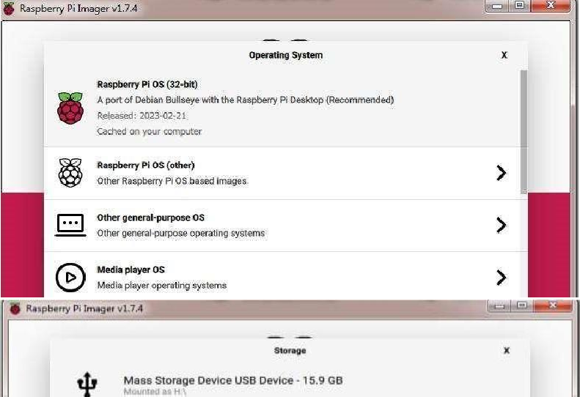

**Step II. Set Host Name, enable SSH, Set Username and Password**

**Step III. Set SSID and Password of hotspot which is used**

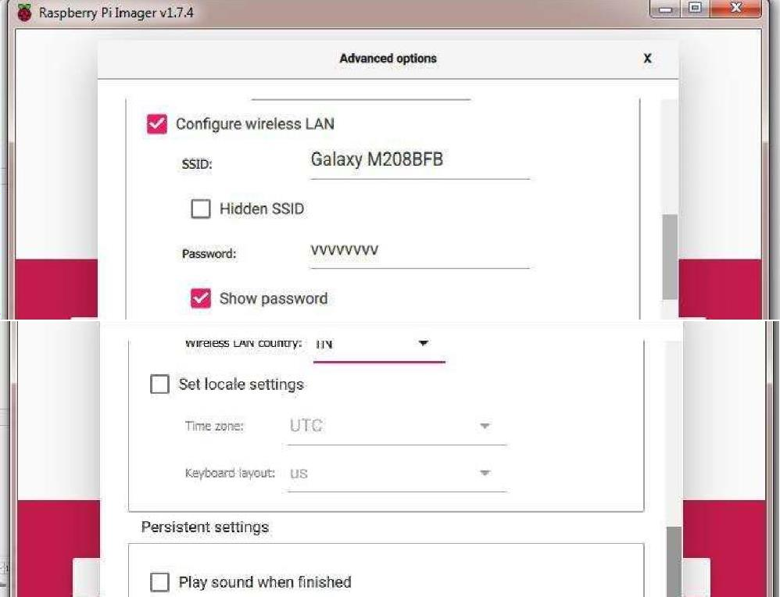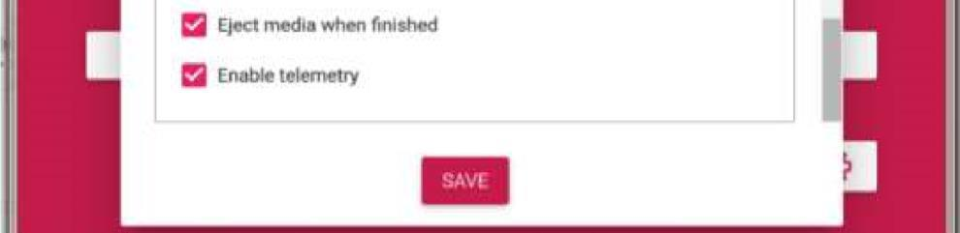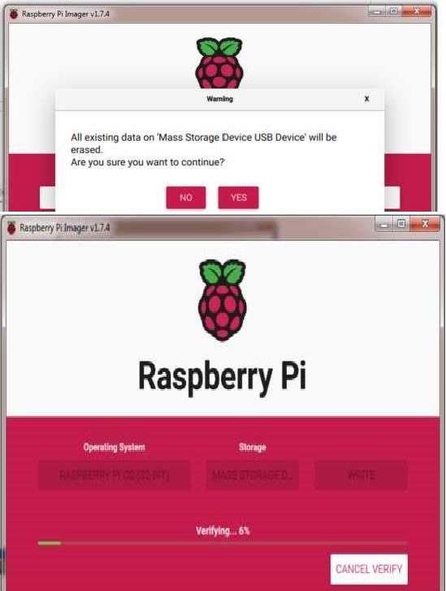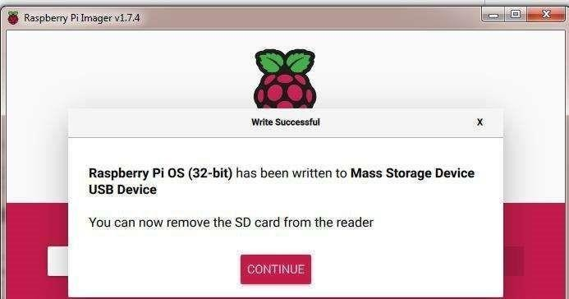

**Step IV. Connection Raspberry Pi WIFI and laptop WIFI to mobile device**

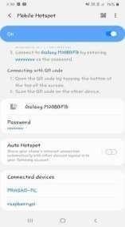

**Step V. Open CMD and tyepe following command**

1. **ping raspberrypi or ping 162.168.207.244**
2. 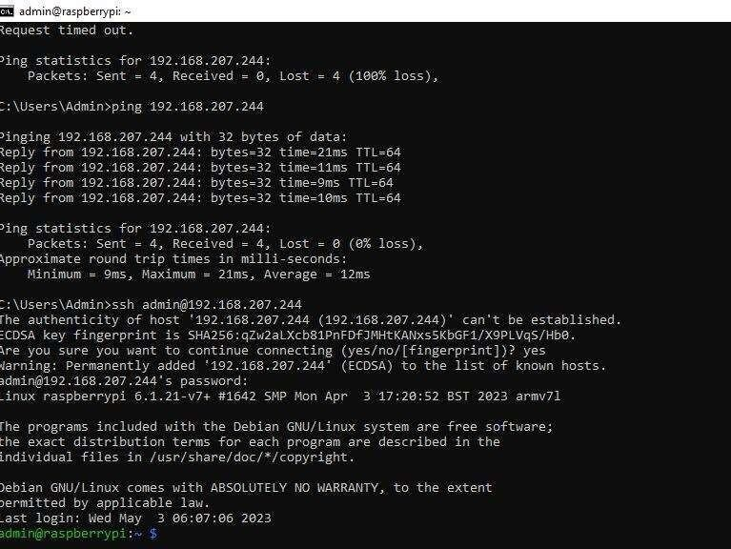**ssh admin@ raspberrypi or ssh admin@ 162.168.207.244 and type password of Admin**

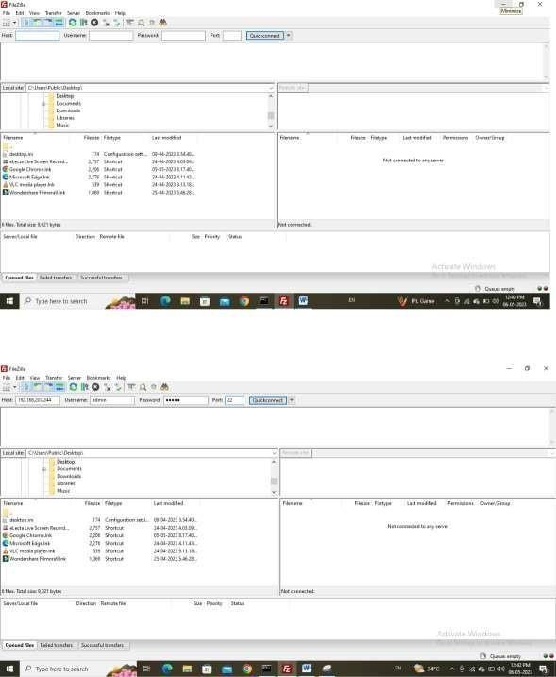**Step VI. Download the FileZilla (Client)**

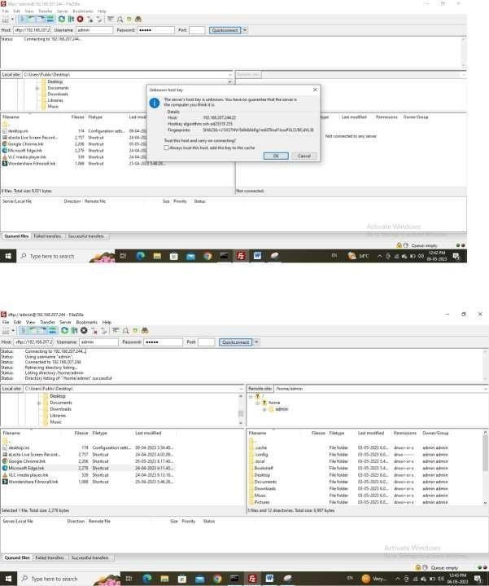



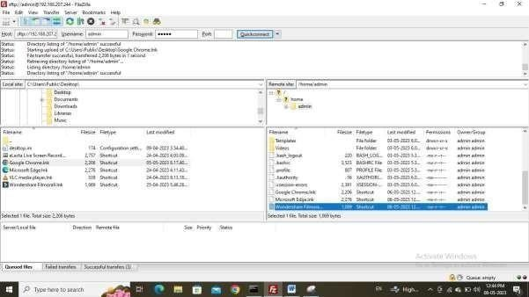

# Practical 3

**Aim**: Write a python code to test motors

**Source Code:**

import RPi.GPIO as GPIO import time GPIO.setmode(GPIO.BOARD)

GPIO.setwarnings(False)button=12 DC_motor_a=7

DC_motor_b=11

GPIO.setup(DC_motor_a,GPIO.OUT) GPIO.setup(DC_motor_b,GPIO.OUT) GPIO.setup(button,GPIO.IN,pull_up_down=GPIO.PUD_UP)

while(1):

if GPIO.input(button)==GPIO.LOW: GPIO.output(DC_motor_a,GPIO.HIGH) GPIO.output(DC_motor_b,GPIO.LOW)time.sleep(0.1)

else: GPIO.output(DC_motor_a,GPIO.LOW) GPIO.output(DC_motor_b,GPIO.HIGH) time.sleep(0.1)

# Practical 4

**Aim**: Write a script to follow a [predetermined](https://www.youtube.com/watch?v=pa7OJsmcvI4) [path.](https://www.youtube.com/watch?v=sO9Yz65dT3U)

**Components:** Raspberry pi Board3, L293D, Simple DC Motor, Button

**Steps:**

**Process of Creation of Project**

**Step I. Go to Proteus, select new project, and change the name of the project and Save As Motors.psdprj**

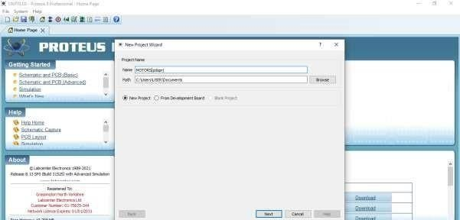

**Step II. Create schema as Default, do not create PCB input and then Create Firmware Project Raspberry Pi -> Click Finish**

**Step III. Implementation of the Circuit – from terminal mode (default, power, ground) and now go to Source code -> Right-Click on RPI3(U1) and click on Add Peripheral then Action Push Button**

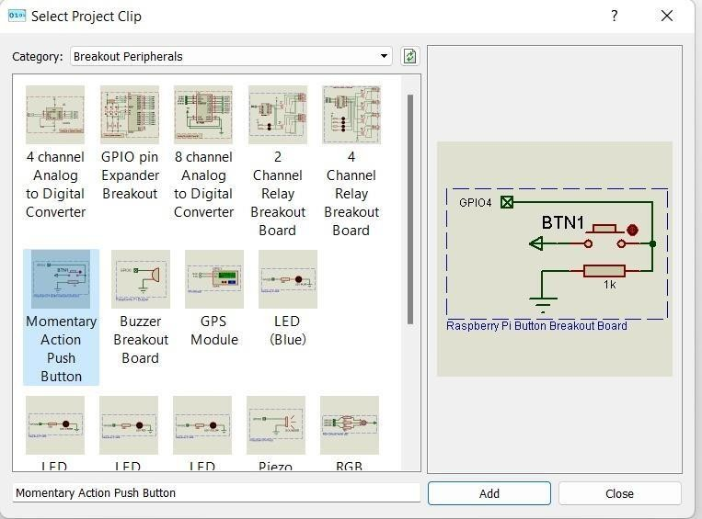

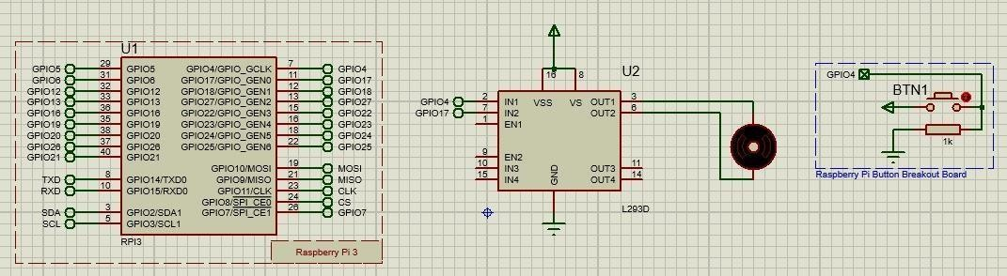

**Source Code:**

import RPi.GPIO as GPIO import time GPIO.setmode(GPIO.BOARD)

GPIO.setwarnings(False)button=12 DC_motor_a=7

DC_motor_b=11

GPIO.setup(DC_motor_a,GPIO.OUT) GPIO.setup(DC_motor_b,GPIO.OUT) GPIO.setup(button,GPIO.IN,pull_up_down=GPIO.PUD_UP)

while(1):

if GPIO.input(button)==GPIO.LOW: GPIO.output(DC_motor_a,GPIO.HIGH) GPIO.output(DC_motor_b,GPIO.LOW) time.sleep(0.1)

else:

GPIO.output(DC_motor_a,GPIO.LOW) GPIO.output(DC_motor_b,GPIO.HIGH)time.sleep(0.1)

**Conclusion:** The movement of the motors are used to represent motion on a path given output –

**Motors moving in Clockwise direction**

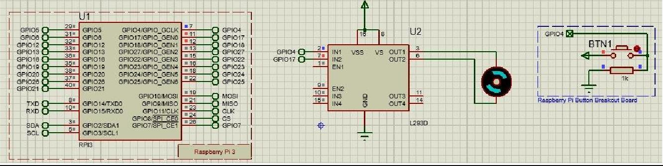

**Motors moving in anticlockwise direction**

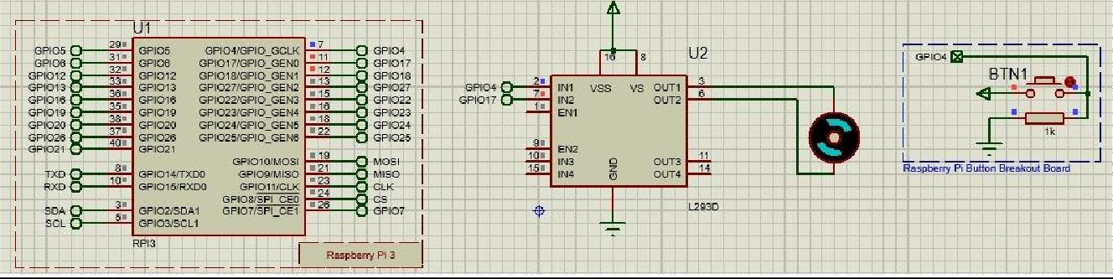

# Practical 5

**Aim**: Develop Python code for testing the sensors.

**Components:** PIR Sensor, Resistor, Piezo, Arduino Uno R3, LED RGB

**Step:**

**Step I. Place the component in TinkerCad.**

**Step II. Type the following code**

int pirsensor = 0;void setup()

{

pinMode(2, INPUT); pinMode(12, OUTPUT); pinMode(13, OUTPUT);

}

void loop()

{

pirsensor = digitalRead(2);if (pirsensor == HIGH)

{

digitalWrite(13,HIGH); tone(12,500,500);

}

digitalWrite(13,LOW)

}

**Output:**

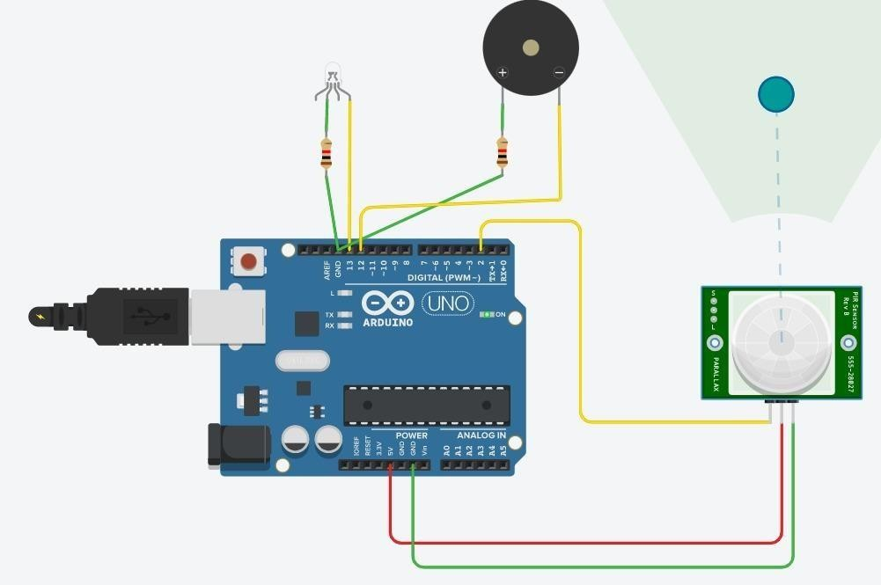

# Practical 6

**Aim**: Add the sensors to the robot object and develop the line follower [behaviour code](https://www.youtube.com/watch?v=iV1tSZCa_e8)

**Components:** Ardinuo, Button, Zumo robot, Proteus 8.13 simulator

**Steps: Process of Creation of Project**

**Step I. Go to Proteus and select new project,**

**Step II. Change the name of the project and save As Linefollower.psdprj that save it and Export Complied Library (open sample of Arduino Zuno line follower)**

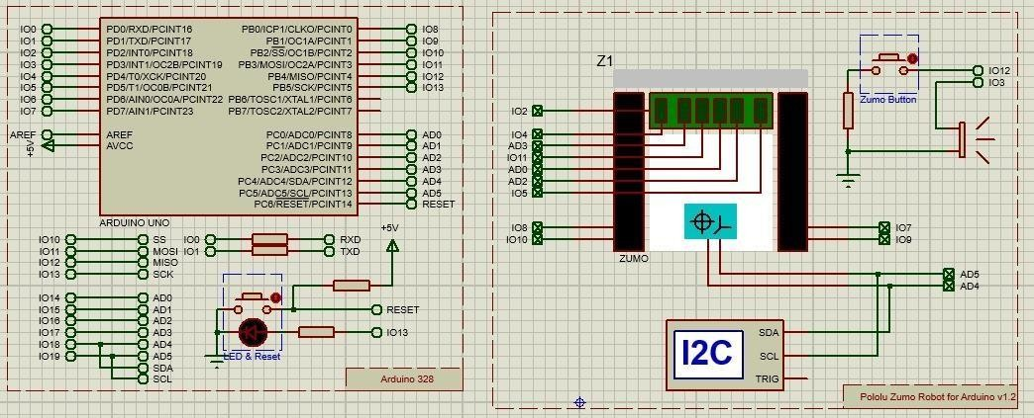**Step III. Upload this HEX file in Arduino**

**Flowchart of Project**

Main Flowchart

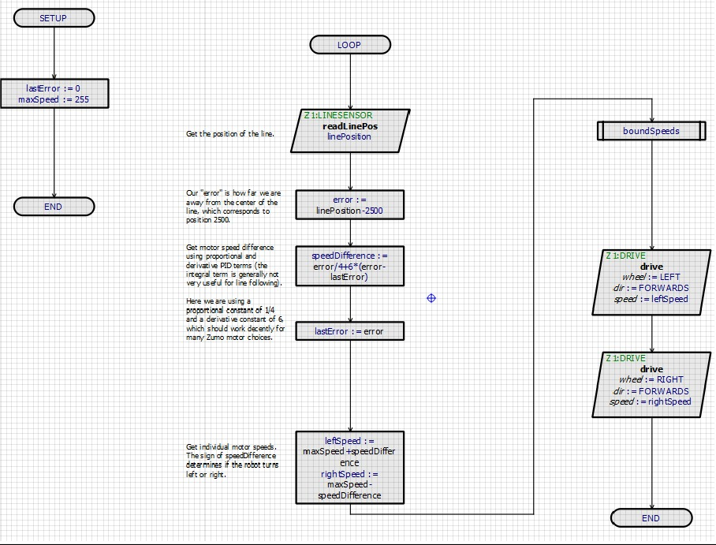

Subroutine Flowchart

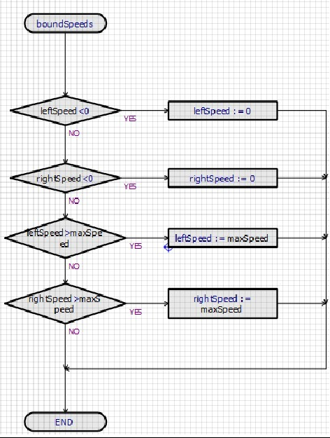

**Source Code**

#pragma GCC push_options #pragma GCC optimize ("Os")

#include <core.h> // Required by cpu#include <cpu.h> #include <TimerOne.h>

#include <L3G.h> // Required by Z1:DRIVE #include

<LSM303.h> // Required by Z1:DRIVE#include <Wire.h>

// Required by Z1:DRIVE #include <Servo.h> // Required by Z1:DRIVE#include <Zumo.h>

#pragma GCC pop_options

// Peripheral ConstructorsCPU &cpu = Cpu;

TimerOne &timer1 = Timer1;

DRIVE Z1_DRIVE = DRIVE (8, 10, 7, 9);

LINESENSOR Z1_LINESENSOR = LINESENSOR (4, A3, 11, A0, A2, 5, 2);COMPASS Z1_COMPASS = COMPASS ();

GYRO Z1_GYRO = GYRO ();

void peripheral_setup ()

{

Z1_DRIVE.begin (); Z1_LINESENSOR.begin ();

Z1_COMPASS.begin (); Z1_GYRO.begin ();

}

void peripheral_loop() {

}

//---CONFIG_END--- //

Flowchart Variables long var_linePosition;long var_error;

long var_lastError;

long var_speedDifference;long var_leftSpeed;

long var_rightSpeed;long var_maxSpeed; float var_magX; float var_magY; float var_magZ;

// Flowchart Routinesvoid chart_SETUP() { var_lastError=0,var_maxSpeed=255;

}

void chart_LOOP() { var_linePosition=Z1_LINESENSOR.readLinePos(); var_error=var_linePosition-2500; var_speedDifference=var_error/4+6*(var_error- var_lastError); var_lastError=var_error;

var_leftSpeed=var_maxSpeed+var_speedDifference,var_rightSpeed=var_maxSpeedvar_speedDifference; chart_boundSpeeds(); Z1_DRIVE.drive(1,1,var_leftSpeed);

Z1_DRIVE.drive(2,1,var_rightSpeed);

}

void chart_boundSpeeds() { if(var_leftSpeed<0) { var_leftSpeed=0;

}

else {

if(var_rightSpeed<0) { var_rightSpeed=0;

} else { if(var_leftSpeed>var_maxSpeed) { var_leftSpeed=var_maxSpeed;

} else { if(var_rightSpeed>var_maxSpeed) { var_rightSpeed=var_maxSpeed;

}

}

}

}

}

// Entry Points and Interrupt Handlers

void setup () { peripheral_setup(); chart_SETUP(); }void loop () { peripheral_loop(); chart_LOOP(); } **Output**

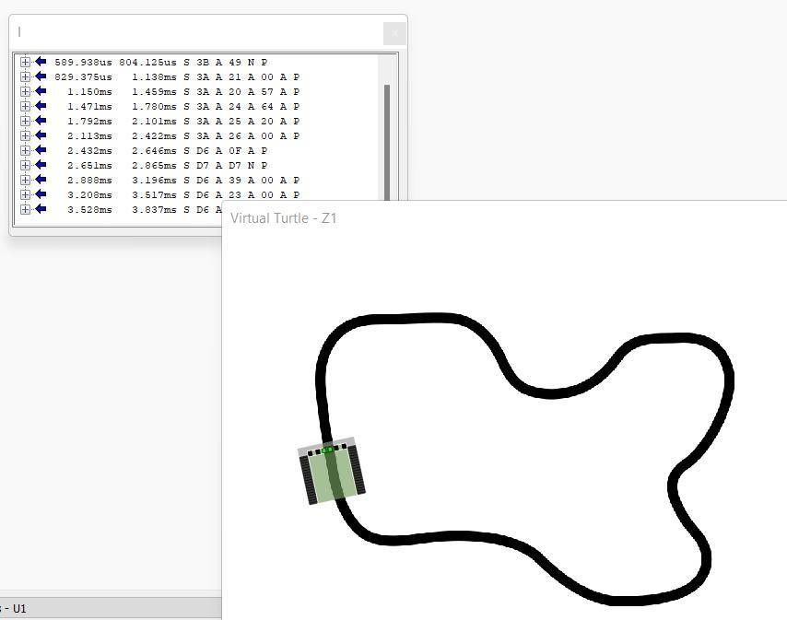

# Practical 7

**Aim**: Using Light strip to develop and debug the line follower robot

**Components:** Raspberry pi, strip RGB LED Circuit

**Procedure:**

**Circuit connection (open samples and select Raspberry Pi Tri Colour LED)**

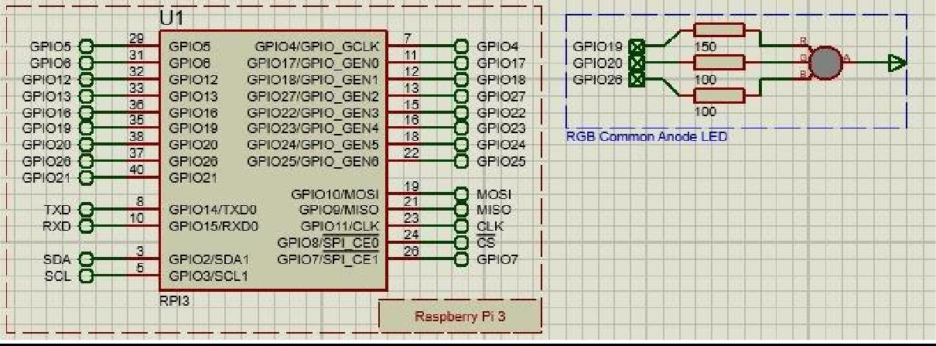

**Source code in python**

from goto import with_gotofrom stddef import * import var import pio import

resource

from datetime import datetime

# Peripheral Configuration Code (Do Not Edit)#--- CONFIG_BEGIN---

import cpu import FileStoreimport timer import VFP import Generic

def peripheral_setup () :

# Peripheral Constructors pio.cpu=cpu.CPU () pio.storage=FileStore.FileStore () pio.timer=timer.Timer () pio.server=VFP.VfpServer ()

pio.RGBLED1=Generic.RgbLedCa (pio.GPIO19, pio.GPIO20, pio.GPIO26)pio.storage.begin () pio.server.begin (0)

# Install interrupt handlersdef peripheral_loop () :

pio.timer.poll () pio.server.poll ()

#---CONFIG_END---

def variables_setup () :

# Flowchart Variablespass # Flowchart Routines

@with_goto

def chart_SETUP () : return @with_goto

def chart_LOOP () :

pio.RGBLED1.set (True, True, True)sleep((500)*0.001) pio.RGBLED1.set (True, False, False)sleep((500)*0.001) pio.RGBLED1.set (True, True, False) sleep((500)*0.001)

pio.RGBLED1.set (False, True, False)sleep((500)*0.001) pio.RGBLED1.set (False, True, True) sleep((500)*0.001)

pio.RGBLED1.set (False, False, True)sleep((500)*0.001) pio.RGBLED1.set (True, False, True) sleep((500)*0.001)

pio.RGBLED1.set (False, False, False)sleep((500)*0.001) return

# Main functiondef main () :

# Setup

variables_setup () peripheral_setup () chart_SETUP ()

# Infinite loop

while True : peripheral_loop () chart_LOOP ()

# Command line execution

if name == ' main ' :main()

**Flowchart:**

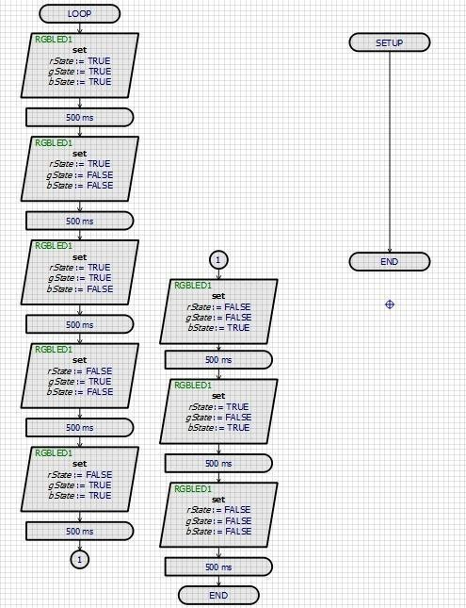

**Output:**

**Figure of the led showing blue color**

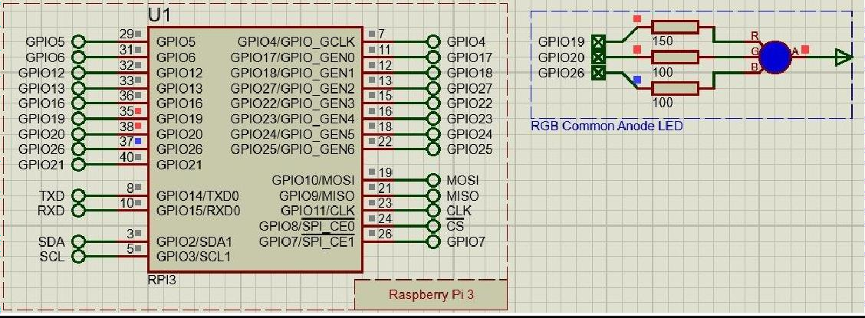

**Figure of the led showing red color**

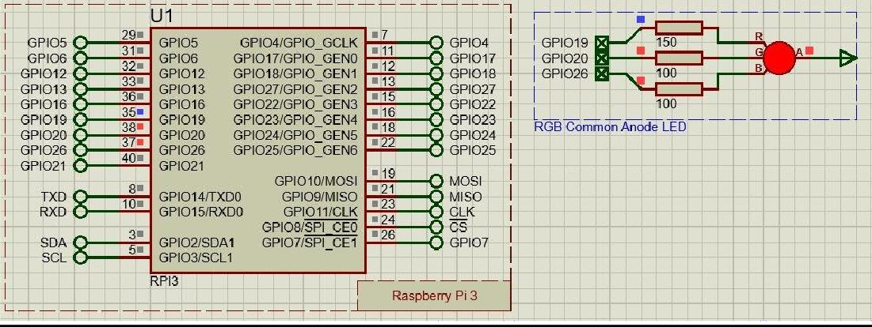

**Figure of the led showing green color**

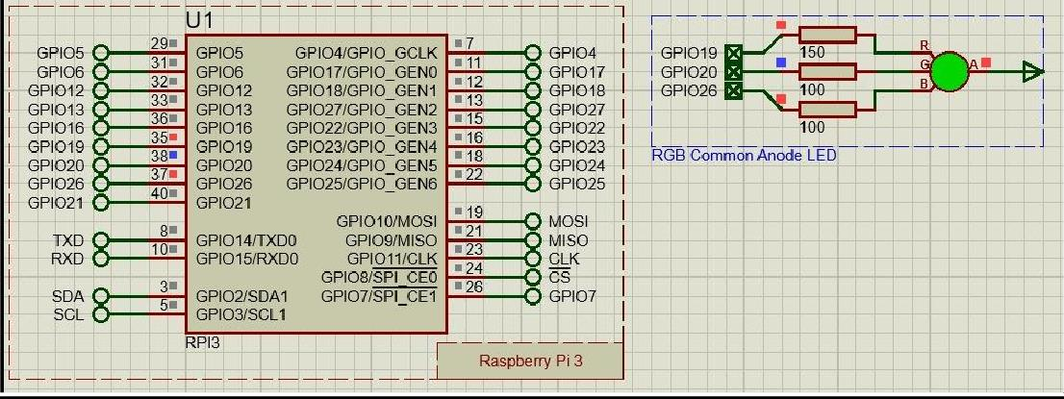

**Figure of the led showing lightblue color**

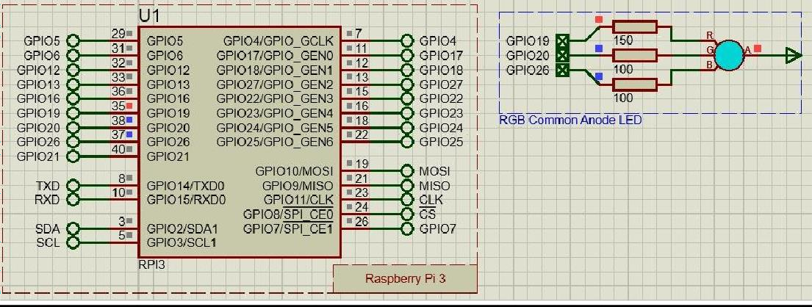

**Conclusion:** Hence we have programmed the RBG strip led for the observation of various colors used to identify the paths.

# Practical 8

**Aim**: Create an obstacle avoidance behaviour for robot and test it.

**Components:** Arduino uno, Zumo robot

**Theory:** Description of Zumo robot- The Zumo robot for Arduino is an Arduino-controllable tracked robot platform. It includes two micro metal gearmotors coupled to a pair of silicone tracks, a stainless- steel bulldozer-style blade, an array of six infrared reflectance sensors for line following or edge detection, a buzzer for simple sounds and music, a 3-axis accelerometer, magnetometer, and gyro for detecting impacts and tracking orientation. The zumo is a more advanced turtle than the Funduino and can perform far better at line following and maze escape challenges but it does not have ultrasonic range finder and therefore is not as well suited to obstacle avoidance challenges.

**Procedure:**

**To create and apply an environment for simulation (use sample Avoid Obstacles)**

1. Draw the required route / obstacles in the graphics package of your choice. Remember that the scale is 1 pixel to 1 mm so drawing a 5-pixel wide line will equate to 5mm in the real world. Width of the line being followed can affect the algorithm (e.g., if all the sensors are never over the line) so it's important to give this some thought.
2. Save the graphic as a PNG file into the same directory as your Proteus project.
3. Edit the turtle component on your schematic and specify the graphic you have just saved as the obstacle map

**Circuit:**

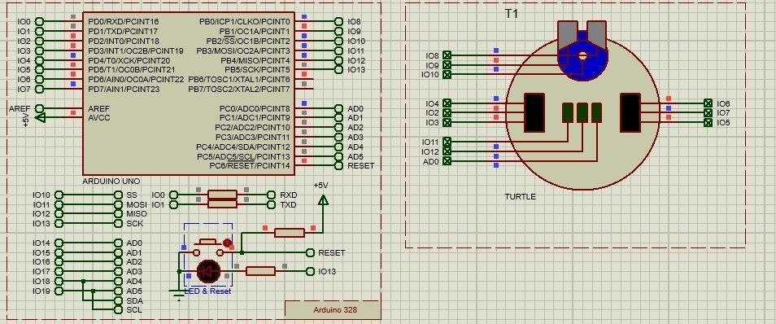

**Source code:**

//---CONFIG_BEGIN---

#pragma GCC push_options #pragma GCC optimize ("Os")

#include <core.h> // Required by cpu#include <cpu.h> #include <TimerOne.h>

#include <Servo.h> // Required by T1: DRIVE#include

<Turtle.h>

#pragma GCC pop_options

// Peripheral ConstructorsCPU &cpu = Cpu;

TimerOne &timer1 = Timer1;

TurtleDrive T1_DRIVE = TurtleDrive (2, 4, 3, 6, 7, 5);

TurtleSonarHead T1_SH = TurtleSonarHead (8, 9, 10); TurtleLineHunter T1_LH = TurtleLineHunter (11, 12, A0);

void peripheral_setup () { T1_DRIVE.begin (); T1_SH.begin (); T1_LH.begin ();

}

void peripheral_loop() {

}

//---CONFIG_END--- //

Flowchart Variableslong var_speed; long var_dir; long var_count; long var_range; long var_fast; long

var_slow; long var_tstart;long var_tstop;

// Flowchart Routinesvoid chart_SETUP() { var_speed=180,var_range=10,var_dir=0;

T1_SH.setAngle(0); T1_SH.setRange(25); T1_DRIVE.forwards(var_speed);

}

void chart_LOOP() { if(!(T1_LH(0,0,0))) { if(T1_LH(1,1,1)) {

chart_Correct();

} else { if(T1_LH(0,1,1))

{

T1_DRIVE.drive(1,1,5*var_speed/4); T1_DRIVE.drive(2,1,var_speed/2); var_dir=10; chart_Avoid();

} else { if(T1_LH(0,0,1))

{

T1_DRIVE.drive(1,1,5*var_speed/4); T1_DRIVE.drive(2,0,var_speed/5); var_dir=30;

} else { if(T1_LH(1,1,0))

{

T1_DRIVE.drive(2,1,5*var_speed/4); T1_DRIVE.drive(1,1,var_speed/2); var_dir=- 10;

chart_Avoid();

} else { if(T1_LH(1,0,0))

{

T1_DRIVE.drive(2,1,5*var_speed/4); T1_DRIVE.drive(1,0,var_speed/5); var_dir=- 30;

} else {

if(T1_LH(-1,1,-1)) {

T1_DRIVE.forwards(var_speed); var_dir=0;

chart_Avoid();

}

}

}

}

}

}

}

}

void chart_Correct() { var_count=0;

l3:;

if(var_dir>0) { T1_DRIVE.drive(2,1,var_speed); T1_DRIVE.drive(1,0,var_speed/3);

} else { if(var_dir<0) { T1_DRIVE.drive(1,1,var_speed); T1_DRIVE.drive(2,0,var_speed/3);

}

}

delay(1); var_count=var_count+1; if(var_count<1000) {

if (T1_LH(1,1,1)) goto l3;

} else { T1_DRIVE.stop(); var_dir=0;

}

}

void chart_Avoid() { if(T1_SH(var_range,0)) { T1_DRIVE.backwards(2*var_speed/3);delay(250);

T1_DRIVE.turn(80);

do {

delay(5);

} while ((!(T1_SH(1.5*var_range,0))) == false);T1_DRIVE.stop(); delay(500);

T1_DRIVE.turn(80);

var_tstart=cpu.millis();

while (!(T1_SH(1.5*var_range,0))) {

}

var_tstop=cpu.millis(); var_count=(var_tstop- var_tstart)/10;T1_DRIVE.stop();

delay(500); T1_DRIVE.turn(-80);

while (var_count>0) { var_count=var_count-1; delay(5);

}

T1_DRIVE.backwards(2*var_speed/3);delay(300); T1_DRIVE.forwards(var_speed/2);

}

}

// Entry Points and Interrupt Handlers

void setup () { peripheral_setup(); chart_SETUP(); }void loop () { peripheral_loop(); chart_LOOP();

**Output for obstacle avoidance using zumo robot:**

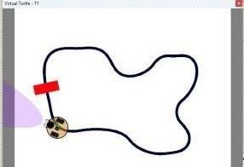

**Conclusion:** Hence the obstacle is avoided using the Zumo robot

# Practical 9

**Aim**: Detect faces with HAAR cascades **Code:** #!pip install opencv_python import cv2

#reading the image

img = cv2.imread("face.jpg")

#converting image to grayscale

gray_img = cv2.cvtColor(img, cv2.COLOR_BGR2GRAY)

#Loading the required haar-cascade.xml classifier file haar_cascade = cv2.CascadeClassifier(cv2.data.haarcascades +"haarcascade_frontalface_default.xml") eye_cascade = cv2.CascadeClassifier(cv2.data.haarcascades +"haarcascade_eye.xml")

faces_rect = haar_cascade.detectMultiScale(gray_img, 1.3, 5)eyes = eye_cascade.detectMultiScale(gray_img)

for(x, y, w ,h) in faces_rect:

cv2.rectangle(img, (x,y), (x+w, y+h), (0,255,0), 1)for(ex, ey, ew ,eh) in eyes:

cv2.rectangle(img, (ex,ey), (ex+ew, ey+eh), (0,255,0), 1)

cv2.imshow('Detected faces', img) cv2.waitKey(0)

**Output:** Hence the face detection is done using HAAR cascades in python



# Practical 10

**Aim**: Using the robot to display its camera as a web app on a phone or desktop and then use camera to drive smart colour and face tracking behaviours.

**Components:** Proteus Simulator 8.9 and above, Lcd TFT, Button, Raspberry pi camera

**Procedure:**

First the components from the library and place it in the schematic chart

Step I. Select new project from the tab, select flow chart project (Open sample and select TFT Display with Camera)

Step II.Create new folder and save the project by remaining as camera.psdrpj in proteus.

Step III. Select a picture and place it in the resource file by right clicking on raspberry pi in the flowchart view

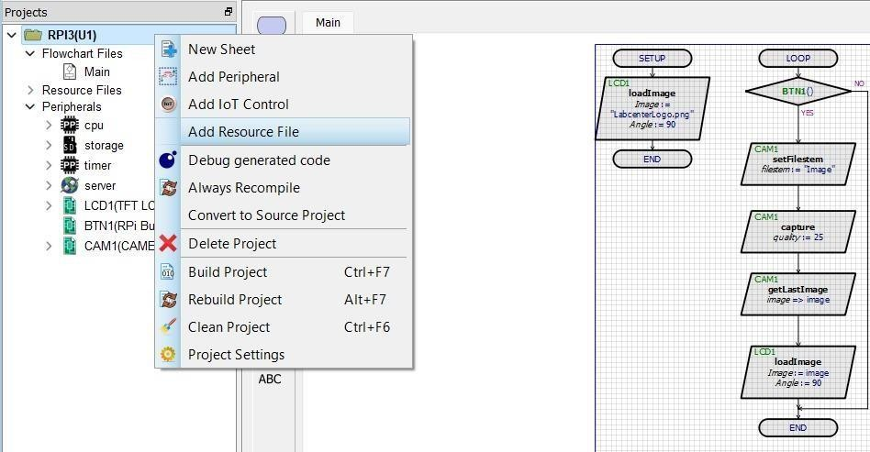

Step IV. Once you click on add resource it will take you to project folder place a bit map image in it. Example shown here is the Labcenterlogo.png

Save it and then run the simulation once you run the simulation you will see the output as shown below Before doing the above process complete the flow chart

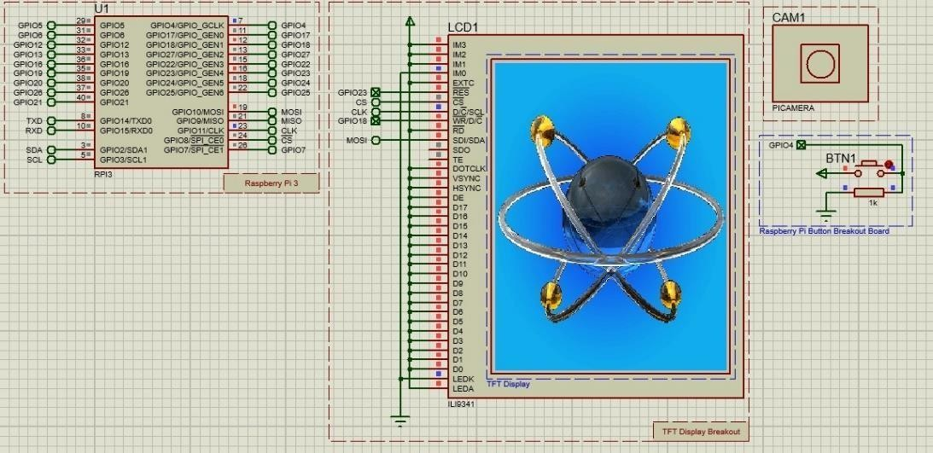 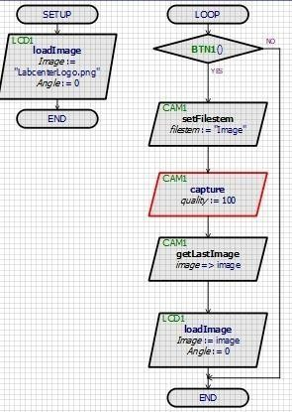

**Flowchart:**

Step V. Once you click the button in the schematic view, we can see our image on the TFT LCD selected. For displaying your image, please keep the camera of the laptop on in case desktop use the web camera

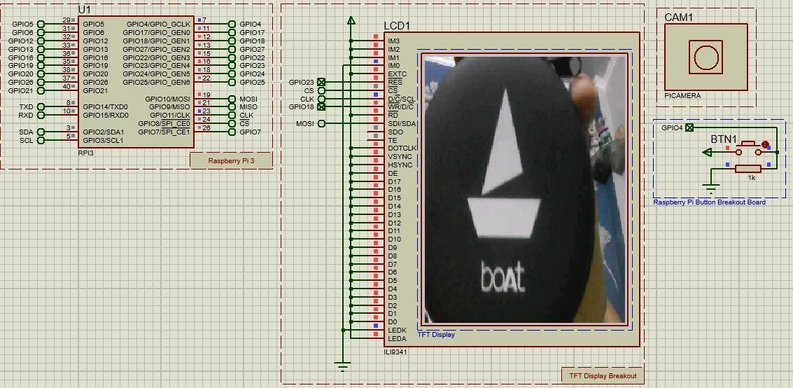

The camera will click the image and display the real time image on the TFT display as shown above.

**Conclusion: -** Hence we have studied the camera function and displayed it using the webapp